JS PRACTICE 02

1. Let’s use bootstrap 5 to create a table with all expected bellow:

Table can `add`, `edit`, and `delete`, `select all`

- Table structure

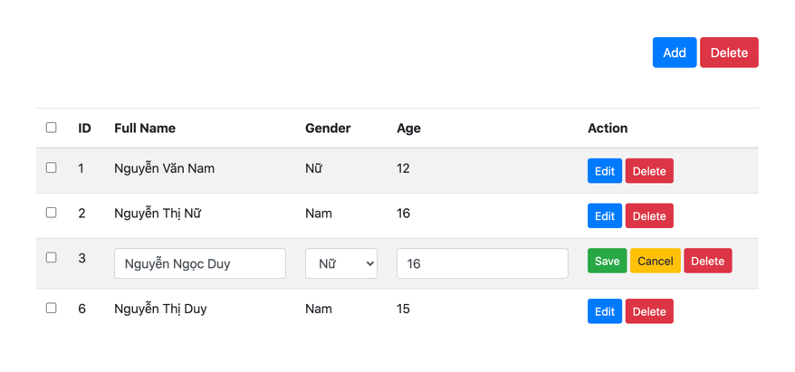

When you click to `edit` button in each row, current row need switch to `edit` mode (show input, select, ...)

- The edit row is a row that have id is equal 3

- In edit mode, `edit` button is hidden, `save` and `cancel` button need to show. You can edit all fields except `id`

- When you click `save` button, current row need back to `read only mode` with new data, then hide `save` and `cancel` button, show `edit` button

- When you click `cancel`, current row need back to old data and back to `read only mode`

- When you click to `delete` in each row, current row need to removed

- When you click to `delete` button in the top of table, all selected row need to be removed

- When you click to `add` button, this table need add new row in the last of table with `edit` mode. You need to create new id to each row, the id need to unique

- Note that: Don't use HTML, you need to use all js to draw table

2.

- In a pokemon match, you just can pick maximum 5 pokemon

- Each pokemon have `HP` and `ATK` numeral that describe bellow

const pokemons = [

{ id: 1, name: 'Charmander', hp: 39, atk: 52 },

{ id: 2, name: 'Pikachu', hp: 35, atk: 55 },

{ id: 3, name: 'Squirtle', hp: 44, atk: 48 },

{ id: 4, name: 'Bulbasaur', hp: 45, atk: 49 },

{ id: 5, name: 'Mew', hp: 100, atk: 100 },

{ id: 6, name: 'Pidgey', hp: 40, atk: 45 },

{ id: 7, name: 'Abra', hp: 25, atk: 20 },

{ id: 8, name: 'Snorlax', hp: 160, atk: 110 },

{ id: 9, name: 'Caterpie', hp: 45, atk: 30 },

{ id: 10, name: 'Dratini', hp: 41, atk: 64 },

{ id: 11, name: 'Eevee', hp: 55, atk: 55 },

{ id: 12, name: 'Jigglypuff', hp: 115, atk: 45 }

]

- illustration (picking Squirtle)

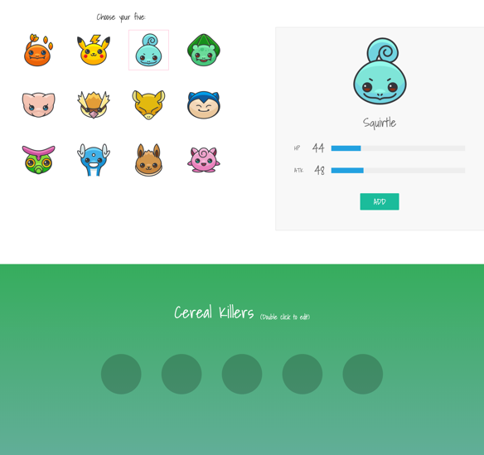

- illustration (picking Pidgey)

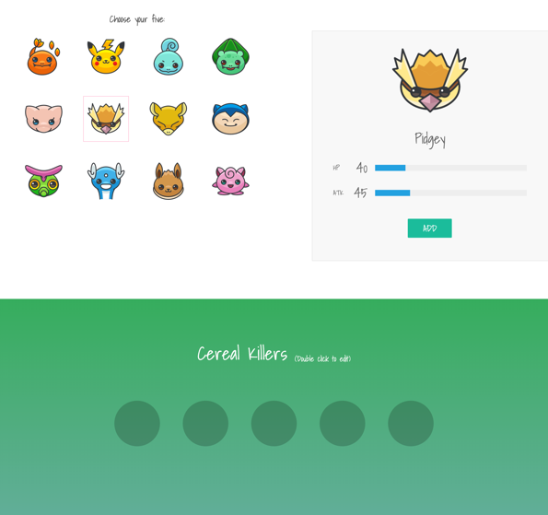

- After click “Add” Pidgey

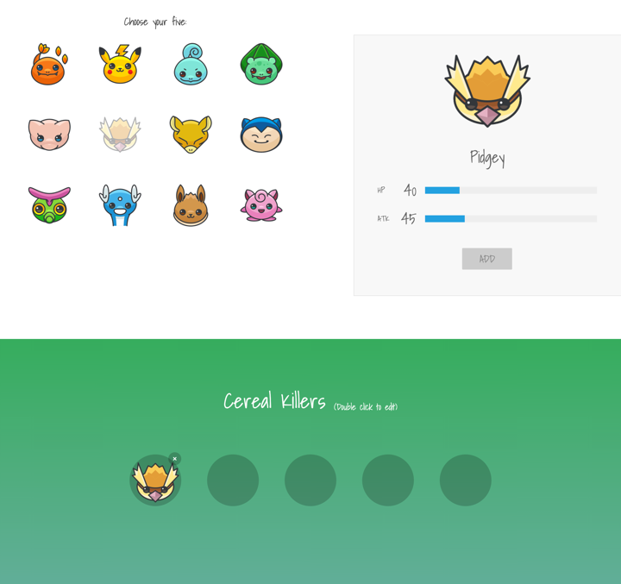

- Button `ADD` need to be disabled

- Cant pick Pidgey again, if you wanna pick Pidgey you need remove Pidgey first

- Pidgey's icon need to be blured

- When you pick pokemon 6th (maximum pokemon can be picked is 5)

Show this text: `You have selected 5 Pokemons.`

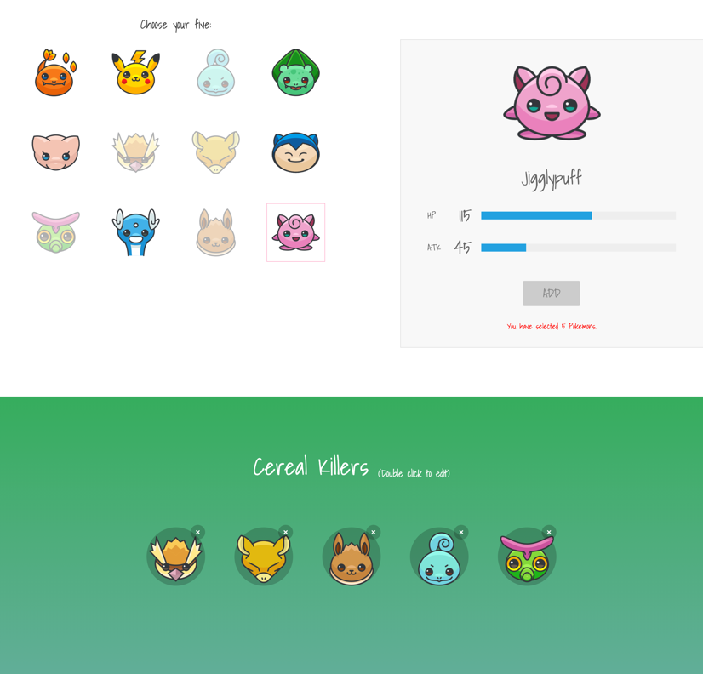

- If you click remove any pokemon that you was pick

- Pokemon will not blurred, you can add pokemon again

- Can remove any pokemon in picked list

- After you remove a pokemon, ex you remove 2nd in picked list, 3rd will be move to 2nd, 4th will be move to 3rd, 5th will be move to 4th

If you double click to "Double click to edit"

- Switch to edit text mode:

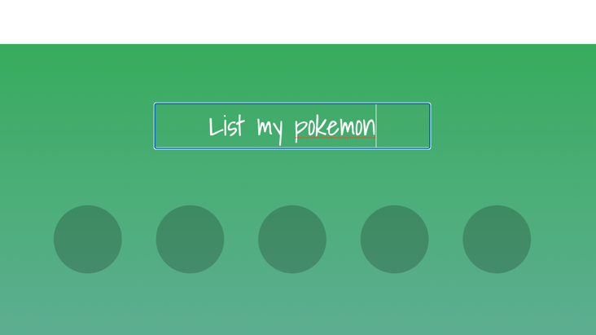

- If you press enter, this display will show new text you was edit before

Note that:

- Don't use HTML, you need to use all js to draw

- Lets use this font to this practice

```css

@import url('https://fonts.googleapis.com/css?family=Roboto:300|Shadows+Into+Light');

```